Laboratory 2 – Week 2
Software Project Development and Tools

Introduction

This worksheet introduces the Software Project Development fundamentals and aims to provide you with a foundational understanding of how programming projects are structured and managed at the technical level. It will explore essential practices for organising, building, and maintaining projects effectively.

Note: It is imperative that you complete this worksheet before going over the actual basics and logic of programming. Doing so will help you structure your project more effectively, especially when you are introduced to various types of programming projects such as building your SwiftBot software (week 5), collaborating in the Group Project and developing in the Programming Applications module (Semester 2).

Basic Anatomy of Projects and Programs

In the previous lab sheet, we created a simple Java project with the following setup.

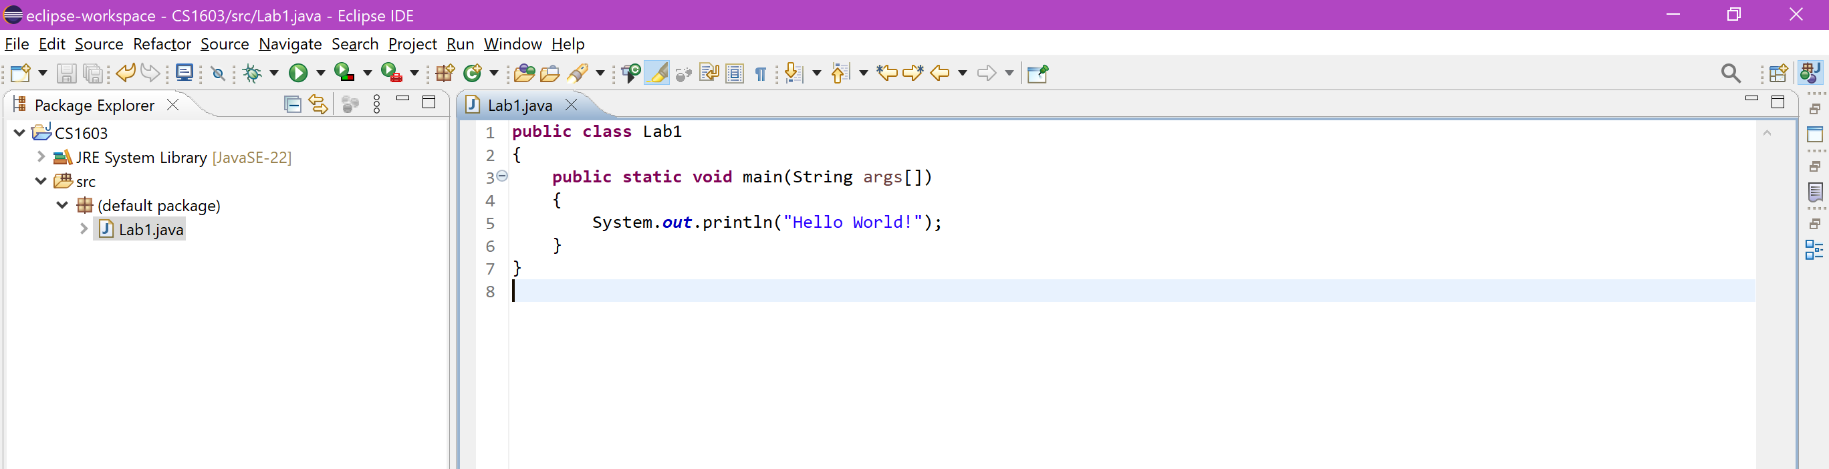

It introduced a simple Java Class and its Main Method.

The basic anatomy (structure/layout) of this project can be inspected by looking at the directory structure in the Project Explorer on the left. However, this is not the true structure, Eclipse (and other IDE’s) abstract many of the underlying project particulars, build configurations, classpath settings, integration with the Operating System (OS) and the system environment.

We can find the proper structure by exiting Eclipse and opening the Windows Explorer to locate the following directory H:\eclipseWorkspace\CS1603.

You can also directly navigate to this folder by right clicking on the Java class we created earlier and clicking on “Show In” > “System Explorer”.

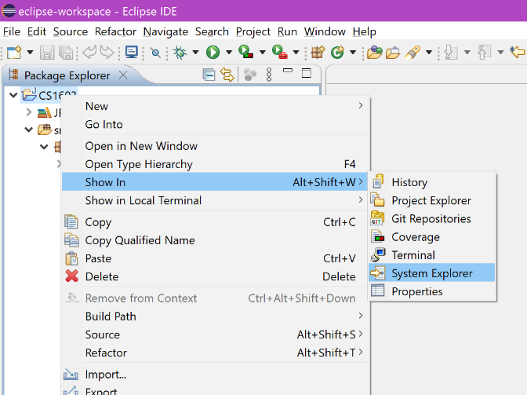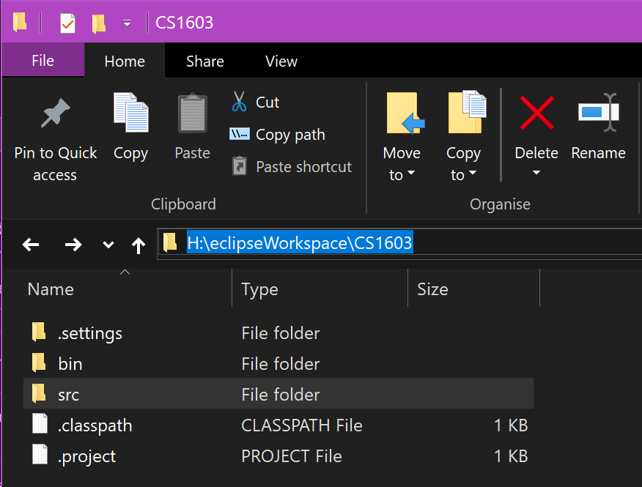

You will see that there are some files and folders present in this directory that Eclipse is not showing.

In this instance H:\eclipseWorkspace\CS1603 shows some files and folders that have a dot. Why do you think this may be ?

(hint: it may not show on the University or your personal machine)

They are hidden folders and files which are used by eclipse to manage the configuration for the project

Open the .project file with a normal text-editor and inspect the file/read the syntax, what language do you think this is and what purpose does it serve?

XML and is used to make the project self-describing meaning it can be correctly recreated in another workspace

A /bin folder is also present, looking at the official online Java documentation (or other sources…), what is this folder for?

Stores the .class files generated by compiling the code

Project Management Tools

Eclipse as an IDE is currently managing our project by automatically setting up a standard Java project structure, compiling our code, and running the program when we press the green “Play” button. For small projects, this built-in management is convenient because it handles many tasks behind the scenes, such as creating the directory structure and ensuring the project is correctly set up for Java development.

For the CS1603 lab sheets, this will be the fundamental mechanism by which you will run, execute and test your code for the CodeRunner examination activities.

Other Tools like Maven and Gradle: Why Do They Exist?

The following instructions are extremely important for your CS1704 – Group Project Module as they will support your primary tasks of working with the Swiftbot.

While Eclipse is great for managing small, individual projects, larger or more complex projects often require more advanced project management, especially when dealing with multiple dependencies, build automation (i.e. SwiftBot!) and team collaboration (i.e. Group Project!).

Therefore, tools such as Maven (https://maven.apache.org/) and Gradle (https://gradle.org/) exist to:
- Automatically download, update, and manage libraries
- Compile, package, and test projects,
- Deliver consistency across different machines and developers.

------------------- SEMINAR ACTIVITY -------------------

Create A Maven Based Java Project

Create a Maven based Java project by navigating to File > New > Maven Project. Make sure to tick “Create a simple project (skip archetype selection)”

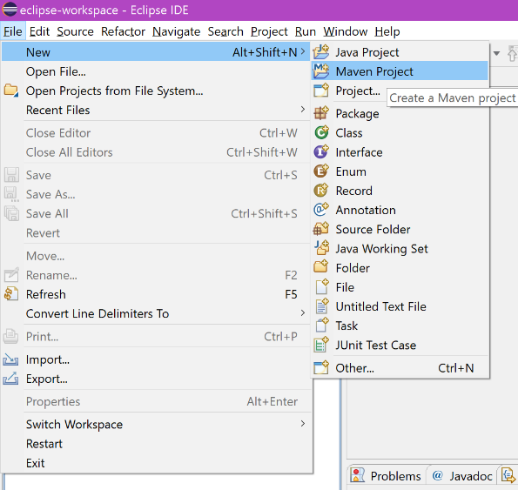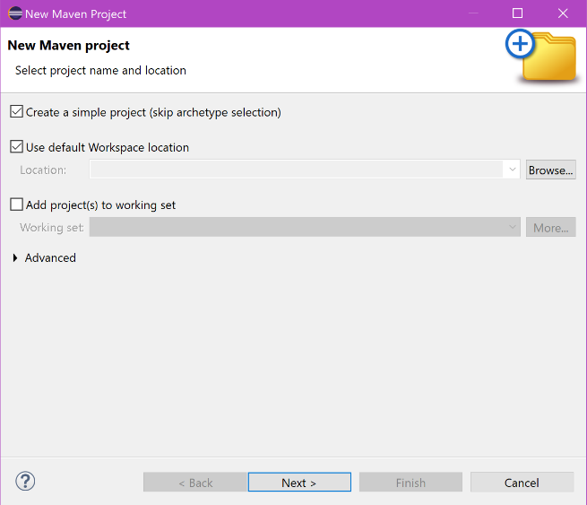

In the project configuration screen, the “Group Id” is used to refer to a collection of projects, for example that of Team 23 in the Group Project. In this case, we set it to “Group-Project-Team-23” as the Group Project and Team 23 will typically have multiple projects with different settings that are all related to each other. The “Artifact Id” is used to refer to an individual project within this collection for example the Swiftbot project.

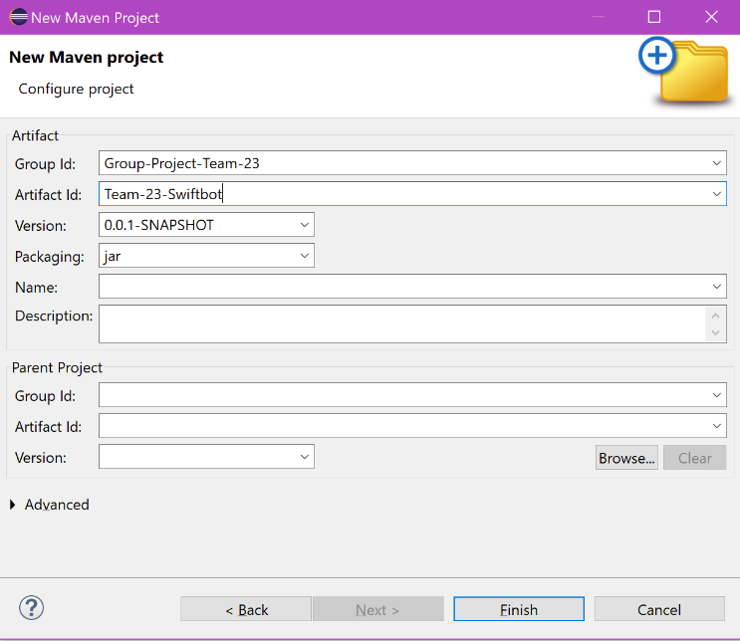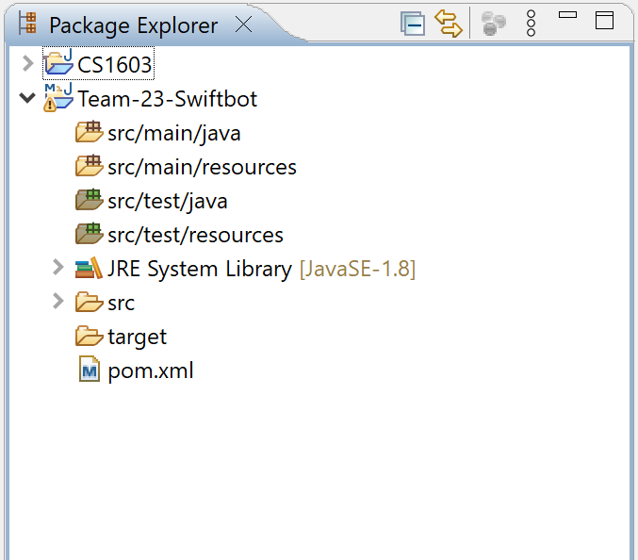

You will see that this project structure is quite different from the standard Java Project the Eclipse IDE sets up for us. Inspect the actual project structure by looking at the folder in the Windows explorer.

What are the differences that you can notice between the standard Java Eclipse and Java Maven project structure?

Multiple src folders

For the Maven project structure, we did not create our first Java Main Class, in which folder would you place the first Java Main class and why?

src/main/java

Create your first HelloWorld.java Class in the new Maven Project Structure and run it.

public class HelloWorld {

public static void main(String[] args) {
System.out.println("Hello World!");
}

}

Does the program run, and if so, are there any differences when running the Lab1.java Class in the CS1603 project?

Yes and there are no differences

From your research what purpose does the pom.xml serve?

Contains information about the project and configuration details used by Maven to build the project

Executing Maven Projects

As mentioned, Maven is just a project management tool, it does not change the underlying Java logic or Eclipse system, and therefore pressing the green play button will still work.

What Maven does very well, is allow us to provide build instructions that have the potential to mass automate system implementation and project configuration. Of course, in our case, we have a simple Hello-world program and therefore is quite trivial. Nonetheless, we can provide these custom instructions by right clicking on the HelloWorld.java class > Run As > Maven Build and enter the following command as the “Goal” and hit run.

install exec:java -Dexec.mainClass="HelloWorld"

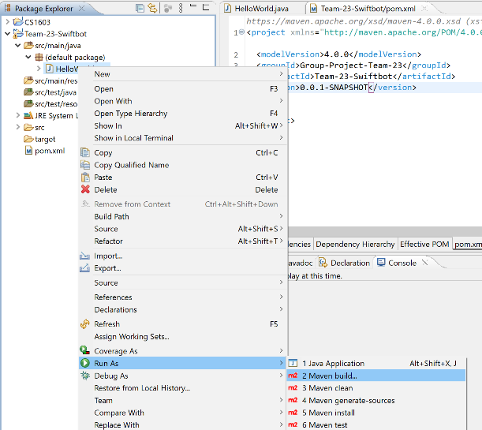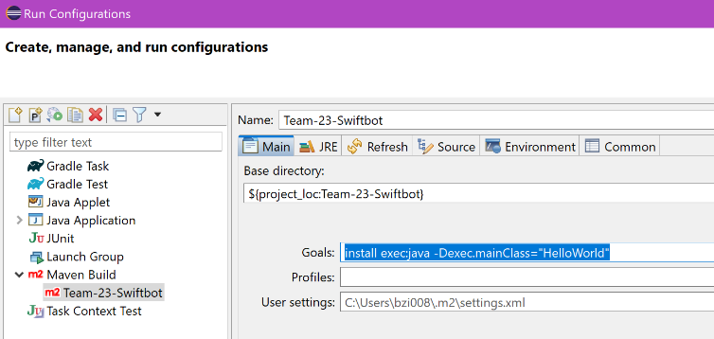

Inspect the console by looking at the [INFO] messages, and notice the coloured output returned by Maven. Specifically, look for the java execution statement and it should return the system print message from the HelloWorld.java.

[INFO] --- exec:3.4.1:java (default-cli) Team-23-Swiftbot ---
Hello World!

Looking at some of the other message we can see a [INFO] message with a “jar”, from your research what is a “jar” file and what is it used for?

[INFO] --- jar:3.4.1:jar (default-jar) Team-23-Swiftbot ---
[INFO] Building jar: C:\Users\bzi008\eclipse-workspace\Team-23-Swiftbot\target\Team-23-Swiftbot-0.0.1-SNAPSHOT.jar

JAR stands for Java ARchive and is a file format based on ZIP and is used for aggregating many files into one

------------------- END SEMINAR ACTIVITY -------------------

Exercises

The following is a short list of tasks aimed at testing your knowledge the standard Java Eclipse project setup and some of the Maven features.

- Using the internet and your own research, complete the Maven project structure tree below by filling in a description of each folder and its purpose.

Note: we have taken the liberty to add one or two items that Maven doesn’t create by default but are very useful considering the upcoming Swiftbot project – can you spot them?

Team-23-Swiftbot/ # Root project directory
│
├── .settings/ # Click or tap here to enter text.
│ └── …
│ └── …
├── src/ # Click or tap here to enter text.
│ └── main/
│ └── java/
│ └── resources/
│ └── test/
│ └── java/
│ └── resources/
├── target/ # Click or tap here to enter text.
│ └── classes/
│ └── …/…
│ └── …/…
│ └── test-classes/
│ └── …/…
├── lib/ # Click or tap here to enter text.
│ └── library.jar/
├── .classpath # Click or tap here to enter text.
├── .project # Click or tap here to enter text.
├── pom.xml # Click or tap here to enter text.
└── README.md # Click or tap here to enter text.

(Next page break….)

Also fill in the standard Java Eclipse project structure tree below. Keep it short.

CS1603/ # Root project directory
│
├── .settings/ # Click or tap here to enter text.
│ └── …
│ └── …
├── bin/ # Click or tap here to enter text.
│ └── lab1/
│ └── Lab1.class
│ └── lab2/
│ └── Lab2.class
│ └── lab3/
│ └── …
├── src/ # Click or tap here to enter text.
│ └── lab1/
│ └── Lab1.java
│ └── lab2/
│ └── Lab2.java
│ └── lab3/
│ └── …
├── .classpath # Click or tap here to enter text.
├── .project # Click or tap here to enter text.
└── README.md # Click or tap here to enter text.

- In the Team-23-SwiftBot\src\main\java, manually add a Testing.java class (Don’t use Eclipse, right click New > Text Document > change .txt extension), what do you notice when you come back to Eclipse after adding the file?

It detects the new java file

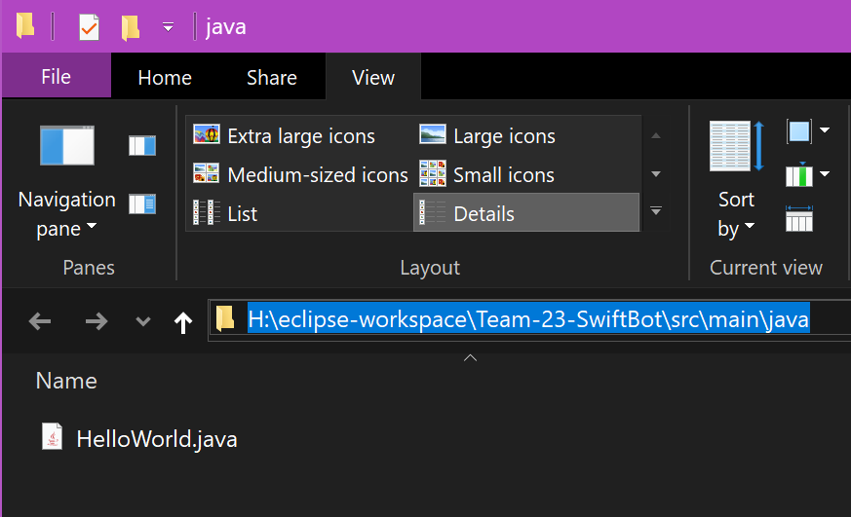

- Add a descriptive comment to the pom.xml file.

- Change the name of the HelloWorld.java program and its class name to something else (perhaps Lab2.java) and run the Maven build again, what happens?

- What are the effects of the clean and install phases?

Maven has multiple build lifecycle phases (e.g., clean, compile, test, install). Run the Maven clean and test phases by right clicking the project and navigating to "Run As > Maven clean..." and "Run As > Maven test...".

Clean removes files created by previous builds and test makes sure that the project can compile

- Check the /target directory after running the original Maven build command from the seminar activity. Now apply a Maven clean command. What happens to the files in the /target folder during these two phases?

install exec:java -Dexec.mainClass="HelloWorld"

They are removed

- Add the following “dependency” to the pom.xml file, and run the Maven build phase again.

<dependencies>
<dependency>
<groupId>net.iharder</groupId>
<artifactId>base64</artifactId>
<version>2.3.8</version>
</dependency>
</dependencies>

What do you notice?

Click or tap here to enter text.

- Try importing the base64 project into the HelloWorld.java program. What does base64 do and why are there two versions available in the content assist window?

Click or tap here to enter text.

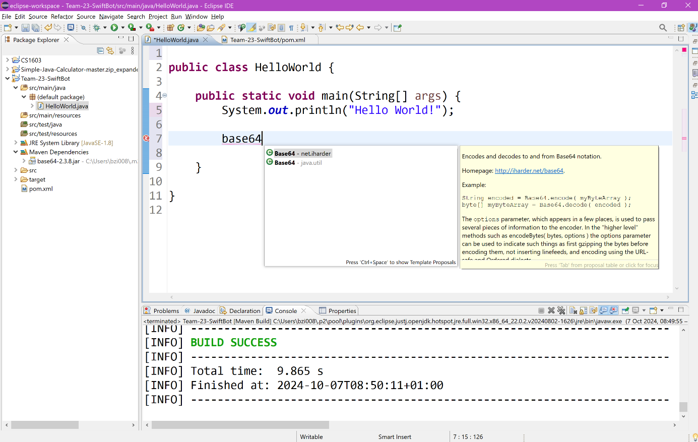

- Identify some other libraries from https://mvnrepository.com/ and import them using the pom.xml

- Where does Maven save and store these external libraries on your pc?

Click or tap here to enter text.

